GALAPAGOS DIVING ITINERARY

8 DAYS / 7 NIGHTS YACHT

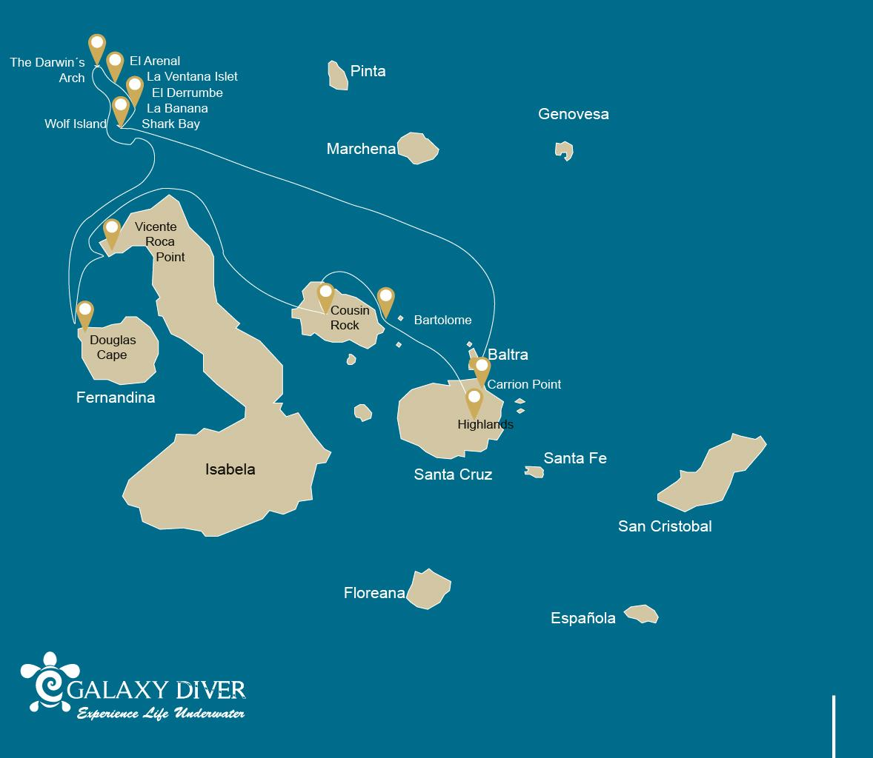

#
DIVING
8 DAYS CRUISE "DIV" | WEDNESDAY | PM | Baltra: Baltra Northeast / Check Dive | 1
 | THURSDAY | AM | Carrion Point | 2
 |  | PM | Navigation: In route to Wolf Island | -
 | FRIDAY | AM | Wolf Island: Shark Bay / La Banana | 2
 |  | PM | Wolf Island: La Ventana Islet / El Derrumbe | 2
 | SATURDAY | AM | El Arenal | 2
 |  | PM | Darwin Island: The Darwin's Arch | 2
 | SUNDAY | AM | El Arenal | 2
 |  | PM | Wolf Island: El Derrumbe, and Shark Bay | 2
 | MONDAY | AM | Isabela Island: Marshall Cape | 1
 |  | PM | Isabela Island: City of Mantas | 1
 | TUESDAY | AM | Santiago: Cousin Rock | 2
 |  | PM | Santa Cruz Island: Highlands | -
 | WEDNESDAY | AM | Santa Cruz: Twins Crater | -

Day 1 – Wednesday / - Arrival at the Gateway to the Enchanting Galapagos Islands
Welcome to the Galapagos Islands, where today marks the beginning of our diving adventure onboard the Galaxy Diver liveaboard yacht. Our journey starts with our arrival at Seymour Airport, also known as Baltra Airport, located on the island of Baltra. As we step off the plane, we'll be greeted by our guide and the friendly staff of the Galaxy Diver, who will help us with our luggage and transfer us to the Galaxy Diver.
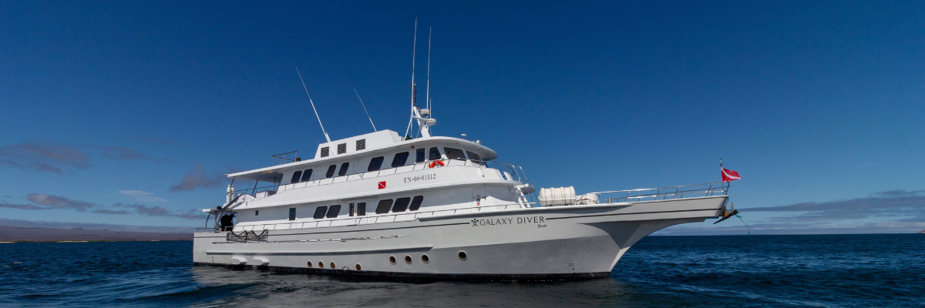
Then, we'll enjoy a delicious lunch and settle into our cabins. But before we dive into the waters, it's important to note that there are strict guidelines for passengers to the archipelago due to the area's designation as a national park. These guidelines help preserve the delicate environment of the Galapagos Islands, ensuring that we can continue to enjoy the beauty of this unique ecosystem for years to come.
After all, we have the safety drill and check dive to try all the equipment by having our first immersion among the wonders of the Galapagos Islands. With the Galaxy Diver as our home base, we'll explore the pristine waters and encounter incredible marine life that can't be found anywhere else. It's sure to be an unforgettable experience that will leave us with memories to last a lifetime.

Meals included | Lunch and Dinner
Lodging | Galaxy Diver Yacht
Difficulty | None
Immersions PM | 1 check dive

Day 2 – Thursday / Carrion Point and en route to Wolf Island - A Diver's Paradise
As the sun rises on our first day of diving aboard the Galaxy Diver yacht, we can feel the excitement building for what's in store at our first dive site, Punta Carrion. We gather our gear, and with the guidance of our expert dive master instructors, we dive into the crystal-clear waters surrounding the stunning Santa Cruz Island.
Descending deeper into the underwater world of Punta Carrion, we'll be immediately mesmerized by the incredible visibility and the abundance of marine life that surrounds us—schools of hammerhead and whale sharks, this last one available between June to December. At the same time, playful sea lions dart in and out of the rocky underwater cliffs.
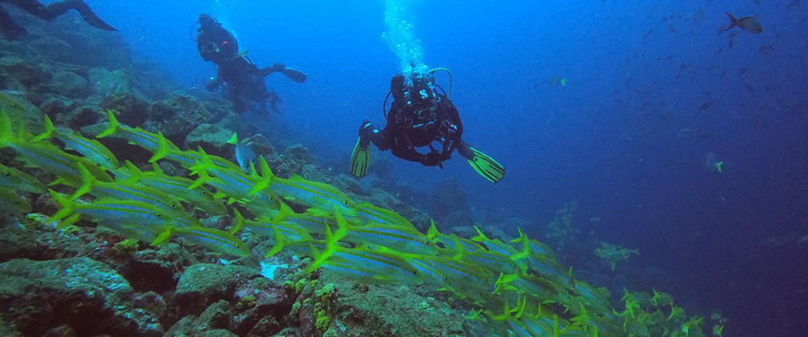
We learn more about the vivid and colorful world of tropical fish as we continue our exploration, including groups of surgeonfish, angelfish, and parrotfish. Luckily, we can even find a few secretive seahorses hidden in the reef's crevices.
Later, we joyfully discuss our underwater excursions. At the same time, the onboard cook makes a lovely lunch when we return to the Galaxy Diver. Finally, in the late afternoon, we'll begin our 14 hours of navigation through the Galapagos Sea to Wolf Island.

Meals included | Breakfast, Lunch, and Dinner
Lodging | Galaxy Diver Yacht
Difficulty | Moderate
Immersions AM | 2

Day 3 – Friday: Shark Bay, La Banana, La Ventana Islet, and El Derrumbe - A Magnificent Marine Expedition
Today, we'll have an exciting diving adventure as we discover the hidden riches of this enchanted location.
Our first stop is the breathtaking Shark Bay, where we can spot the majestic Galapagos shark, eagle ray, and sea lion will meet you as you plunge into the ocean's depths. These magnificent creatures are a sight to behold, with exquisite movements that will take your breath away.
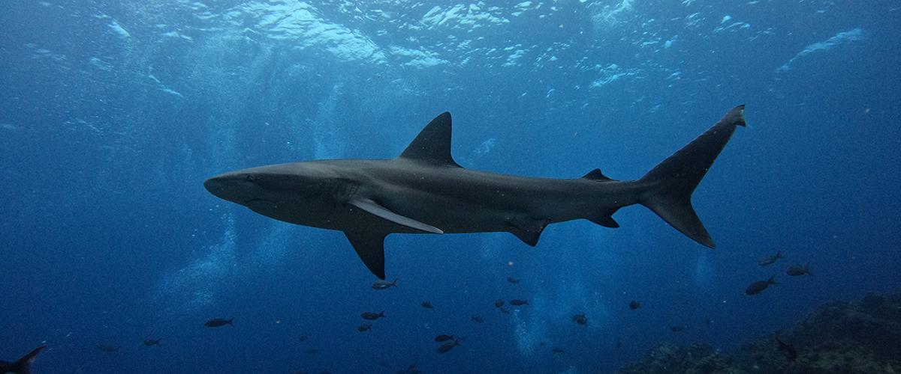
Following a thrilling morning dive, we'll travel to La Banana to continue our journey and discover the Galapagos Islands' abundant marine life. In addition, we'll be able to see playful sea lions in their native environment, darting and whirling about us with elegant, engaging, and mesmerizing beauty.
As the day unfolds, we'll make our way to La Ventana Islet and El Derrumbe, two diving locations known for their diverse marine life. Go into the fascinating world of colorful fish, turtles, and sea stars as they welcome you into their natural home. The beauty and magic of the undersea environment will wow you as you explore these hidden jewels.
As we wrap up our diving day, take a minute to enjoy the beautiful sunset while reflecting on the incredible experiences of the day. The Galapagos Islands are indeed a treasure trove of natural beauty, and we are privileged to accompany you on this magnificent voyage. Therefore, be ready to immerse yourself in a world of wonder and go on a once-in-a-lifetime experience!

Meals included | Breakfast, Lunch, and Dinner
Lodging | Galaxy Diver Yacht
Difficulty | Moderate
Immersions AM | 2
Immersions PM | 2

Day 4 – Saturday: El Arenal and The Darwin's Arch - A Journey of Discovery
Today, we'll take you to El Arenal. This magnificent location will leave you spellbound by the natural beauty of the Galapagos Islands. A diving site considered one of the best diving points in the world. This site is close to Darwin's Arch and offers moderate to strong currents with depths ranging from 46 to 121 ft and visibility from 40 to 80 ft. As you dive deeper into the sea, you'll be greeted by the impressive Galapagos underwater biodiversity.
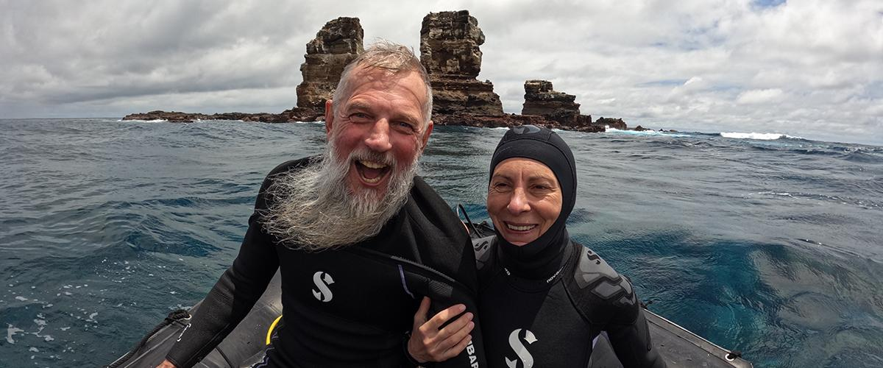
We'll then move on to Darwin's Tower, commonly known as Darwin's Arch, one of the most iconic dive sites in the world. This awe-inspiring location is a must-visit for any avid diver. We're thrilled to share this incredible experience with you. As you dive into the deep blue waters, a world of vibrant coral, schools of colorful fish, and the majestic beauty of the hammerhead shark will be waiting for you with their imposing presence and graceful movements.
The thrill of diving at Darwin's Tower is indescribable, and you'll be amazed by the sheer beauty of this underwater wonderland.

Meals included | Breakfast, Lunch, and Dinner
Lodging | Galaxy Diver Yacht
Difficulty | Moderate
Immersions AM | 2
Immersions PM | 2

Day 5 – Sunday: El Arenal, El Derrumbe, and Shark Bay - A Marine Adventure
Our first dive site of the day is El Arenal. As we explore the vibrant coral reefs and discover the diverse marine life, we'll have the chance to encounter an incredible array of species. Some of them could be dolphins commonly sighted feeding on schools of fish, hammerhead sharks, whale sharks, rays, Galapagos sharks, and even tiger sharks and killer whales. But the beauty of El Arenal isn't just in its impressive marine life; the geological formations are also a sight to behold.
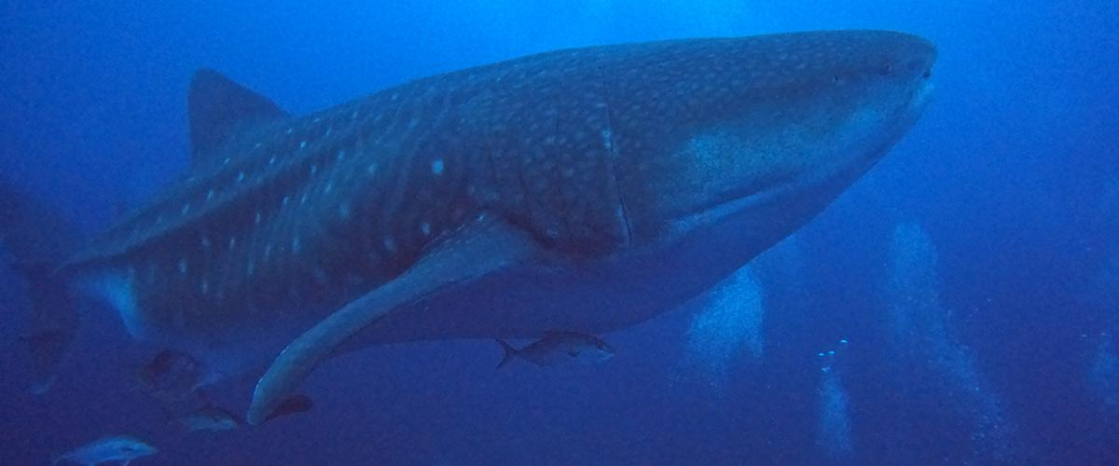
After an exhilarating morning dive, we'll move on to El Derrumbe, where we'll discover the fascinating marine diversity of the Galapagos Islands. This site offers a unique diving experience with its underwater cliffs and caves. You'll encounter many species, including green turtles, sea lions, and eagle rays. But what makes this site truly special is the presence of bull sharks, one of the few places in the world where you can dive with them in shallow waters.
Our last dive of the day takes us to Shark Bay, where we'll explore the hidden treasures of the Galapagos Islands. This site is famous for its incredible diversity of marine life, including the Galapagos shark, eagle ray, and sea lion. But what makes this site truly unique is the presence of whale sharks that visit the Galapagos Islands every year from July to November. It's a rare opportunity to witness these gentle giants, and we're honored to share this experience with you.

Meals included | Breakfast, Lunch, and Dinner
Lodging | Galaxy Diver Yacht
Difficulty | Moderate to Advance
Immersions AM | 2
Immersions PM | 2

Day 6 – Monday: Marshall Cape

The itinerary for Cabo Douglas and Punta Vicente Roca has been changed since September 20, 2023, due to a contingency conservation plan for the species on this island. In its place, visits will be made to Cabo Marshall and Manta City, both recognized for their abundant flora and fauna. This itinerary will return to normal once the Galapagos National Park deems it optimal for the reception of guests again.

Marshall Cape is an iconic location in the Galapagos Islands, especially known for its majestic volcanic walls that plunge into the ocean's depths. This underwater landscape becomes a sanctuary for large schools of fish and graceful manta rays that dance in the waters. Popular among divers, Cabo Marshall, as it is known in Spanish, offers a unique diving experience, thanks to the currents and the rich biodiversity these waters house.
Diving: Its volcanic walls provide shelter to various marine species. It's not uncommon to encounter schools of hammerhead sharks, barracudas, and, of course, the elegant manta rays that call this spot home.
Highlights: Underwater volcanic walls, manta rays, schools of fish, and hammerhead sharks.
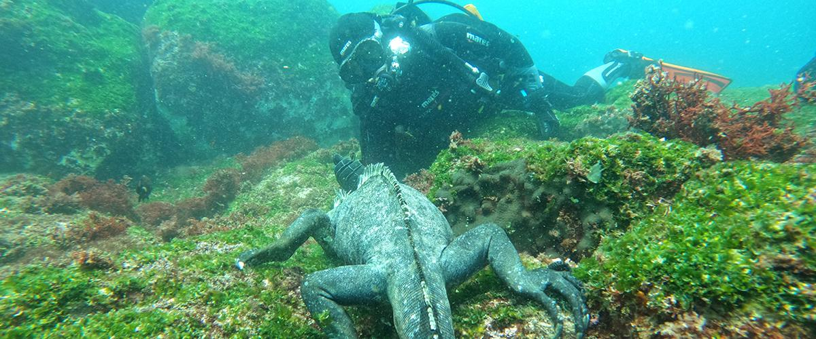

City of the Mantas: It's one of the hidden gems of the Galapagos Islands, a site that, as its name suggests, is famous for its encounters with manta rays. This destination offers visitors the chance to immerse themselves in a deep blue world, where giant manta rays, along with other marine residents, glide gracefully and majestically. The area, besides being a sanctuary for these creatures, is a biodiversity spectacle, with colorful corals and tropical fish complementing the scene.
Diving: Provides an even more intimate experience with marine life, where the sensation of floating among manta rays becomes a tangible reality.
Highlights: Manta rays, rich coral reefs with diverse marine fauna.

Meals included | Breakfast, Lunch, and Dinner
Lodging | Galaxy Diver Yacht
Difficulty | Moderate
Immersions AM | 1
Immersions PM | 1

Day 7 – Tuesday: Cousin Rock and Santa Cruz Highlands - An Adventure to Remember
This morning we'll have the opportunity to do our last dive at Cousin Rock—one of the most colorful dive sites in the archipelago. The vibrant coral walls and gorgonians create a stunning backdrop for encounters with seahorses, reef fish, and various nudibranchs. Keep an eye out for the curious coral hawks as they dart around the reef. As we dive deeper, we might glimpse a school of eagle rays gracefully gliding by or spot a white-tip shark resting in a crevice. If we're lucky, we might even see mobulas and schools of barracudas. Finally, the playful sea lions will appear and invite us to join their underwater games.
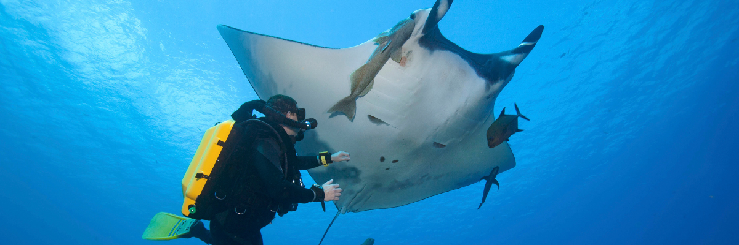
After lunch, we disembark and head for a reserve in the Santa Cruz Highlands. Here, we have the unique opportunity to witness the iconic Galapagos Tortoise in its natural habitat. Walking through the lush vegetation, we might even spot some of the other residents of the highlands, like the elusive Galapagos Rail or the bright Vermilion Flycatcher.
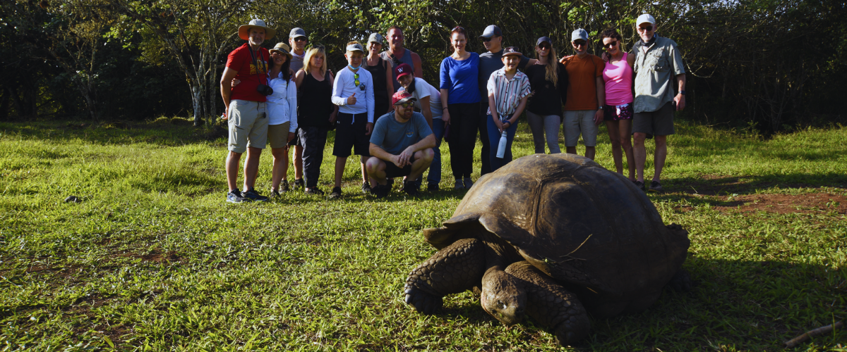

Meals included | Breakfast, Lunch, and Dinner
Lodging | Galaxy Diver Yacht
Difficulty | Moderate
Immersions AM | 2
Immersions PM | None

Day 8 – Wednesday: Baltra Airport - A Farewell to the Enchanting Galapagos Islands
After a week of unforgettable experiences, it is time to bid farewell to this enchanting land. As you'll be transferred to Baltra Airport, take the memories of a lifetime and the magic of the Galapagos Islands.

Meals included | Breakfast
Lodging | None
Difficulty | None
Immersions AM | 0
Immersions PM | 0

